Assignment 10: Projectiles

- A cannon is placed on level ground. It is aimed 30 degrees above horizontal. The cannonball leaves the cannon with an initial speed of 250 m/s.
  - What is the horizontal component of the initial velocity (v_{ix})?

  - What is the vertical component of the initial velocity (v_{iy})?

  - What is the time it takes the cannonball to reach its maximum height?

  - What is the maximum height of the cannonball?

  - What is the total time of flight for the cannonball?

  - How far from the cannon does the cannonball land?

- A golfer hits a ball on a level golf-course at 25 m/s, 40° above horizontal.
  - What is the amount of time it takes the golf-ball to reach its maximum height (hint: find v_{ix} and v_{iy} first).

  - What is the total time the golf ball is in the air?

  - How far away does the golf ball land?

- Kay is attempting to kick a football through the field-goal posts. She kicks the ball at 18 m/s at a 35° angle to the ground. She is 20 meters from the goal-post.
  - What are the initial vertical and horizontal velocities of the football?

  - How long does it take the football to travel the distance to the goal post? (Hint – does this depend on the vertical direction or the horizontal direction?)

  - What is the height of the football when it passes the goal-post?

  - Does she score 3 points for her team?

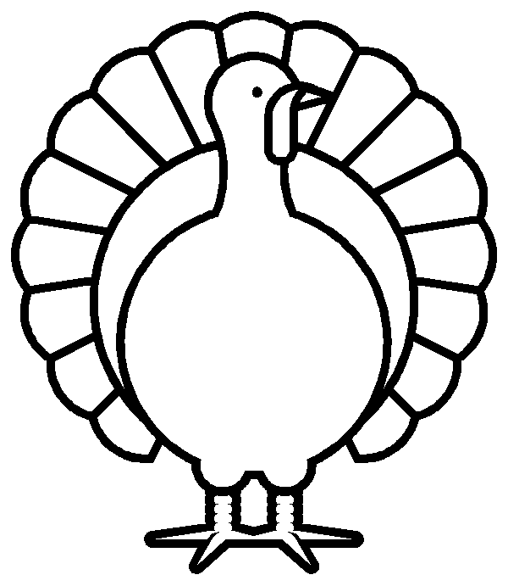
- Briana is hunting wild turkeys. She sees a turkey sitting on a branch at the top of a tree that is 20 meters away. She aims her bow at a 25° angle, and shoots the arrow with a speed of 50 m/s. The turkey is hit, and falls to the ground. Briana picks up the turkey and takes it home to save for thanksgiving dinner.
  - What are the initial vertical and horizontal velocities of the arrow?

  - How long does it take for the arrow to hit the turkey?

  - How high up was the turkey sitting?

  - How long does the turkey take to fall to the ground?

